**ANNUAL GENERAL MEETING**

Notice is hereby given that the 2025 Annual General Meeting of the League will be held at the **Moat House**, Lower Penkridge Road, Acton Trussell, ST17 0RJ

on **Saturday 29th November 2025** at **11:30**

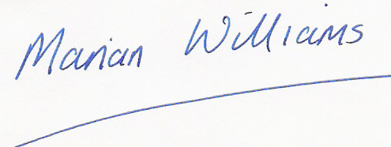

Marian Williams

League Administrator

The business of the AGM shall be in accordance with rule 11.1 & 11.2 of the league’s constitution.

For clarification, all motions, and nominations for Officers or the Management Group, submitted by Clubs or Composite Teams must be sent in writing to the league administrator by 09:00 on 31st October 2025 at the latest. They must be submitted on club headed notepaper signed by two officers of the Club, or the YDL representative and one other officer of the Club, with the agreement of the Club’s Management Committee.

Motions must be supported by at least 5 additional Clubs or Composite teams. (Composite teams are considered to be one club, and any resolutions must have the agreement of all members of the composite.)

The following positions are due to be elected this year:

* Vice Chair (currently Tim Soutar serving as a casual vacancy) - to serve to 2029
* General committee members:
  + Midlands Area Co-ordinator (currently covered by Marian Williams) – to serve to 2027
  + Northern Area Co-ordinator (currently covered by Nicola Thomson) – to serve to 2026
  + Scottish Co-ordinator (currently Leslie Roy) – to serve to 2027
  + Finals Co-ordinator (currently Arwel Williams serving as a casual vacancy) – to serve to 2026
  + Results Co-ordinator (currently unfilled and covered by League Administrator) – to serve to 2027
  + One further vacancy to serve to serve to 2027

All the above positions will require a nomination for election.

Further information will be sent out and added to the UKYDL website in due course.